**Social Media Posts**

**Post Option 1**

What if you could power your home and save money at the same time? With the increases in electricity and gas currently seen across the country and cost of living on the rise, it almost sounds too good to be true. It doesn’t have to be – a Plico solar + battery solution can be your answer.

Starting from $30.90 per week (with no big upfront cost), you’ll get solar panels, a solar battery, servicing and maintenance for 10 years and access to your energy during day, night and during blackouts.

Speak to the switched-on people at Plico to find out exactly how much you can save on your energy bills. Plus, because they’re friends of ours, they’re going to waive the $250 membership fee when you join. Find out more: LINK

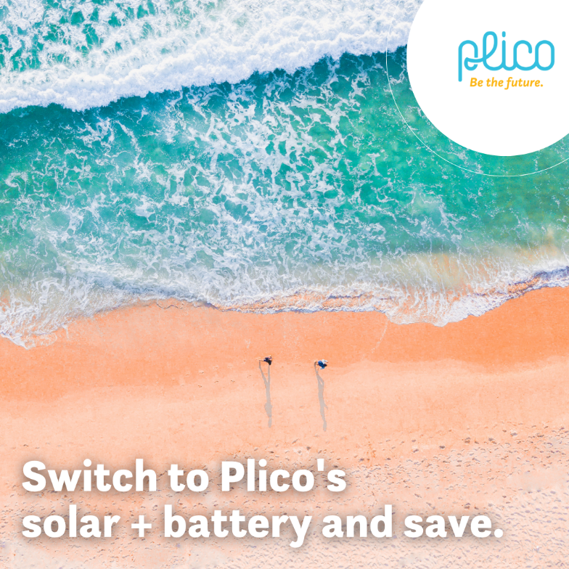

**Post Option 2**

Don’t wait to make energy savings. Plico’s solar + battery system is installed with no big upfront installation costs so you could start seeing saving straight away.

Starting from $30.90 per week, you can enjoy capturing, storing and using your own clean energy with your Plico solar + battery solution. If you already have existing solar panels, you can retrofit a battery from as little as $19.90 per week. Plico is here for the long haul providing service and maintenance for the 10 years you’re with them.

Plus, because they’re friends of ours, they’re going to waive the $250 membership fee when you join.

Follow the link to find out more: LINK  


**Post Option 3**

It’s an unfortunate truth that the incidences of blackouts in WA are on the rise. Did you know that a solar + battery solution can keep you connected during a blackout? You could be the envy of your neighbours by being the only home with the lights left on during the next blackout.

Our friends at Plico want to make it even easier to keep your lights on so they’re waiving the $250 membershipwhen you join. Speak to the switched-on team to find out more: LINK

